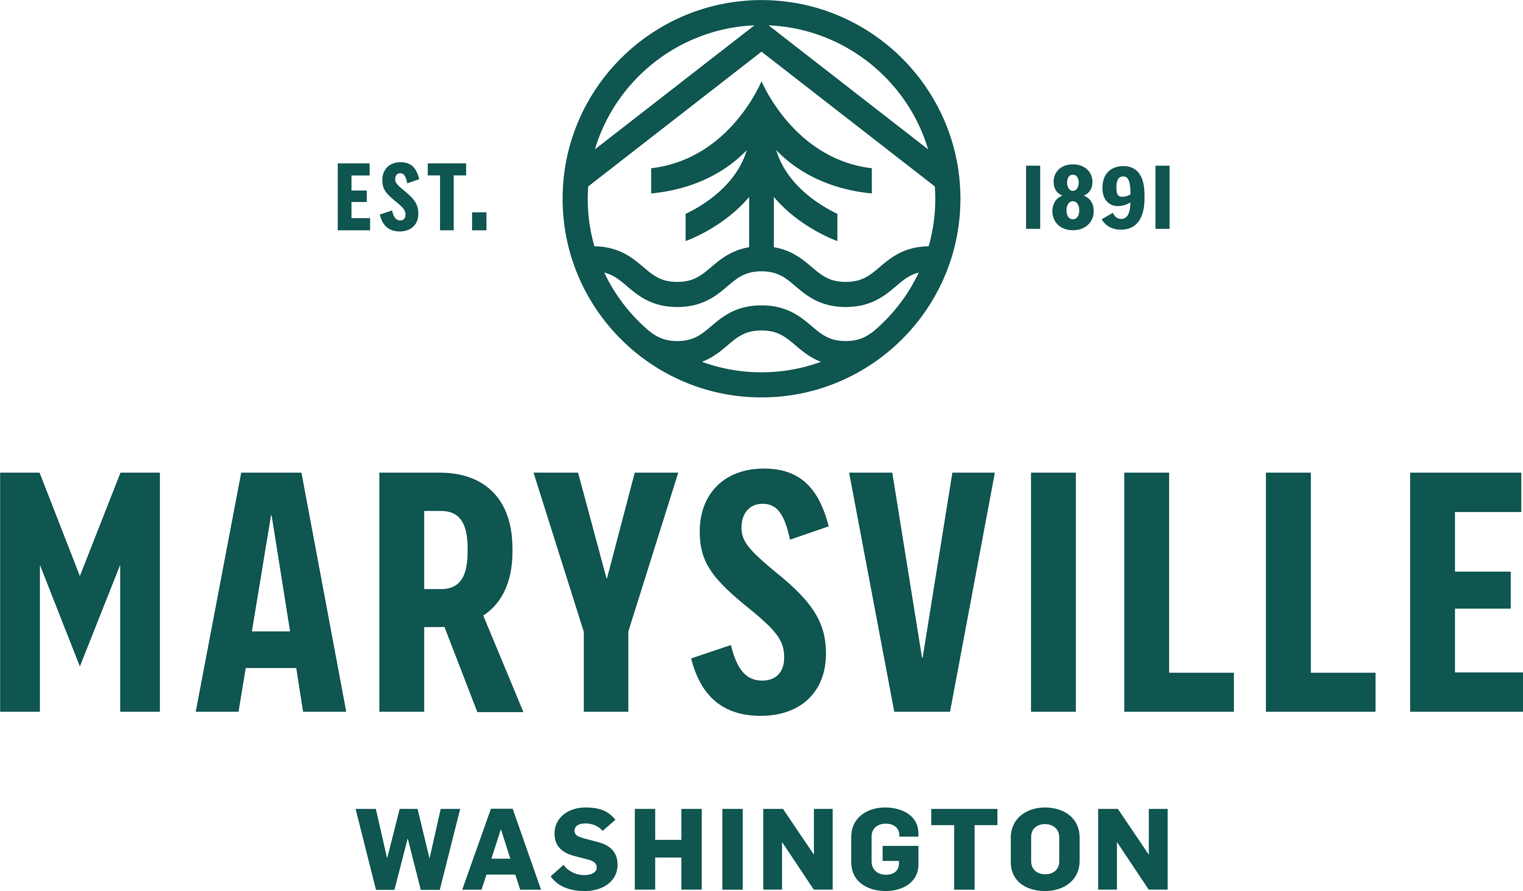

Organization: City of Marysville
Position Title: Utilities & Maintenance Services Director
Address: 501 Delta Ave, Marysville, WA 98270
First Review: Rolling interviews until April 5, 2026
Salary: $209,694 - $263,061 annually DOQ

The City of Marysville, WA is seeking a Utilities & Maintenance Services Director for this rapidly growing community located 35 miles north of Seattle along the I-5 corridor. As the second-largest city in Snohomish County, Marysville offers convenient access to major economic centers such as the Port of Everett and Boeing Field, while still maintaining small-town charm and access to the quintessential Pacific Northwest lifestyle.

THE CITY OF MARYSVILLE

Marysville is a full-service city serving a population of 76,000 across 20 square miles with a 2025 budget of $213 million and a team of 389 FTEs. Departments include Executive, Legal, HR, Finance, Information & Geographic Systems, Engineering Services, Community Development, Police Department, Marysville Municipal Court, Utilities & Maintenance Services, and Parks, Culture, & Recreation.

THE UTILITIES & MAINTENANCE SERVICES DIRECTOR

Reporting to the City Administrator, the Utilities & Maintenance Services Director is responsible for the overall vision, direction, and leadership of the Utilities & Maintenance Services Department. The department oversees the City’s Water, Stormwater/Surface Water, Wastewater, and Solid Waste utilities, as well as Maintenance Services, which includes parks, fleet, and facilities maintenance operations.

WHY APPLY
The Utilities and Maintenance Services Director position offers a unique opportunity to serve as a transformational leader within the City of Marysville. The Director will lead the Utilities and Maintenance Services Department as they embark on an ambitious capital improvement program to support the needs of this fast-growing community. The City benefits from a stable political environment and a committed and supportive executive team who are guided by collaboration and empowerment. Departmental staff are engaged and eager to continue the work underway to realign operations and enhance service delivery. For a leader committed to change management and seeking a career-defining opportunity, Marysville offers the chance to make a lasting impact within a supportive, family-friendly community, positioning the City for excellence now and into the future.

View the full position profile, job description, and benefits at gmphr.com.

More Information: GMP Consultants is assisting the City of Marysville with this search. Learn more at gmphr.com. The City of Marysville is an Equal Opportunity Employer. Rolling interviews until April 5, 2026.

